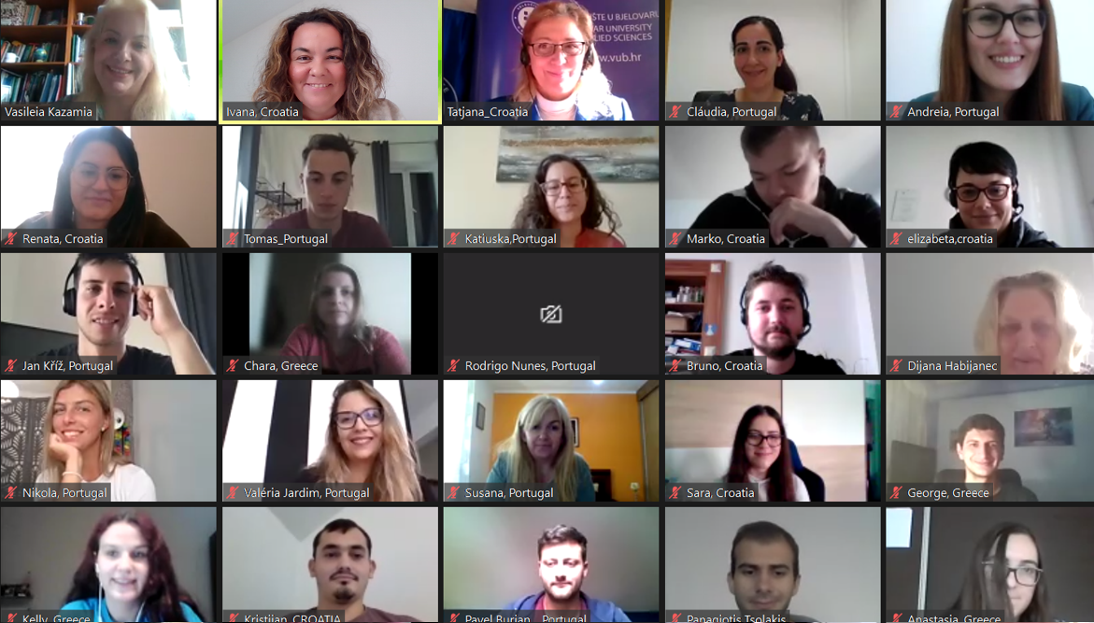

|  |
| --- |
|  |
| - COURSE CURRICULUM -  Improving communication skills in a digital, international  environment |
| Intellectual output 2  Project:  2020-1-HR01-KA226-HE-094728  Authors:  Tatjana Badrov, MSc Andreia Carvalho, M. A. Ivana Jurković, M. A. Vassilia Kazamia, PhD |

|  |  |  |  |
| --- | --- | --- | --- |
| Course title | | Intercultural Communication and Linguistic Upgrade in a Digital Environment | |
| Duration | | 5 weeks | |
| Course objective | | | |
| This course intends to provide students with tools that enable them to work in interdisciplinary and multicultural teams in a digital environment, training them on how to overcome communication barriers that may arise in such contexts. | | | |
| Expected learning outcomes | | | |
| Upon the completion of the course in Intercultural Communication and Linguistic Upgrade in a Digital Environment, the learners will be able to:   * Recognize cultural differences * Effectively communicate in multicultural teams * Be familiar with video conferencing tools * Deliver an effective and engaging presentation in a digital environment * Know what interdisciplinary communication is and what it requires * Recognize interdisciplinary communication barriers and resort to strategies to overcome them * Know the basics of teamwork mindset and behaviour * Be familiar with teamwork challenges and ways to overcome them * Develop communication and presentation skills in an intercultural and intersectoral scenario * Acquire other soft skills | | | |
| Course implementation conditions | | | |
| Group size: 30 students  Teachers: At least one Language or Communication Skills teacher  Spatial conditions: All participants (teachers and learners) should have access to a computer / laptop or smartphone with camera and microphone and Internet connection.  Other conditions: Not applicable | | | |
| Course content | | | |
| 1. INTERCULTURAL COMMUNICATION AND THE ROLE OF LANGUAGE   · Key concepts related to intercultural communication  · English as *lingua franca*  · Cultural stereotypes and generalisations  · High-context cultures and low-context cultures  · Global Competence   1. VIDEO CONFERENCING TOOLS   · Different types of communication in a digital environment  · Communication standards of various digital tools  · The work of an international team in a digital environment  · The rules of appropriate behaviour and participation in video conferencing   1. INTERDISCIPLINARY COMMUNICATION   · Typical scenarios  · Jargon leading to misunderstanding and ineffective communication  · Strategies to overcome communication barriers in an interdisciplinary environment  · Interdisciplinary communication and teamwork   1. TEAMWORK   · Definition and characteristics of teamwork  · Teamwork mindset and behaviour  · Key points of team dynamics theory  · The potential of individual attributes of team members (how to discover and acknowledge them)  · Challenges of teamwork and how to handle them  · Techniques and strategies for overcoming teamwork breakdown situations  · Multicultural teamwork issues   1. PRESENTATION SKILLS   · Delivering an effective presentation in a digital environment  · Audience awareness  · Cultural attitudes | | | |
| Forms of instruction | ☐x lectures  ☐x practical sessions  ☐x seminars and workshops  ☐x distance learning  ☐x mentoring | | ☐ individual work  ☐x group work  ☐x multimedia  ☐ other ___________________ |
| Learners' obligations | | | |
| To complete this course, learners must:   * Attend the sessions * Participate in an active way * Work in multidisciplinary teams * Respect multicultural differences * Complete the assignments * Meet the deadlines | | | |
| Assessment | | | |
| The assessment consists in a collaborative project where learners work in interdisciplinary and intercultural teams in a digital context.  Example 1: Students present a video on teamwork mindset or interdisciplinary communication breakdown situations.  Example 2: Students create and present a video on the advantages and challenges of engaging in effective cross-cultural interactions.  Example 3: Students present a video on do’s and don'ts when video conferencing.  Example 4: Students present an animated video based on a dialogue between professionals from different fields, which serves as an example of effective/ineffective communication in an intersectoral environment. | | | |
| Literature used for developing the course curriculum | | | |
| •Fornaro, R. J., Heil, M. R., and Peretti, S. W., “Enhancing Technical Communication Skills of Engineering Students: An Experiment in Multidisciplinary Design,” In *Proceedings of the 31st ASEE/IEEE Frontiers in Education Conference*, October 2001, Reno, NV.  •Hornby Albert Sydney; WEHMEIER, Sally. (eds.), (2005), *Oxford Advanced Learner’s Dictionary* (7th ed.), Oxford: Oxford University Press;  •Johnson, Christine (2005). *Intelligent Business Intermediate Skills Book and CD-ROM pack*, United Kingdom: Pearson Education Limited.  •Trappe, Tonya; Tullis, Graham (2010). *Intelligent Business Intermediate Coursebook/CD Pack*, United Kingdom: Pearson Education Limited.  •Wilson, V. and Pirrie, A., “Multidisciplinary teamworking indicators of good practice,” *Spotlights,* vol. 77, 1999, pp. 1-4. | | | |
| Required reading | | | |
| • Badrov T., Carvalho A., Jurković I., Kazamia V. (2021). *Intercultural Communication and Linguistic Upgrade in a Digital Environment*, Bjelovar: Bjelovar University of Applied Sciences (available in English, Croatian, Greek and Portuguese) | | | |

|  |  |
| --- | --- |
| 1. WORKSHOP TITLE | Intercultural communication in a digital environment |
| 1.1. Planned learning outcomes  - concrete and precise articulation of what learners will know, understand and be able to demonstrate upon the completion of the learning process | Upon the completion of the workshop, the learners will be able to:   * participate in the work of the international team   + - * recognize the difference between one's own perception of one's own country and the perception of persons of other nationalities       * to connect the positive perception of one's own country from team members from other countries with the positive emotions that are a prerequisite for harmonious work in an international team       * discuss perceived differences in perception in a non-destructive way       * communicate with team members from different countries respecting differences       * identify possible stereotypes and discuss them in a respectful way * analyse the advantages and disadvantages of intercultural communication in live from those via video conferencing |
| 1.2. Workshop content  Main topics that will be covered in the workshop | Part 1- Introduction   * Information about the workshop; aim, activities and expected results * Agreement on the mode of operation * Presentation of team members by google form questionnaire   Part 2- Get to know each other   * Formation of intercultural teams * Permissions   Part 3 – Intercultural communication in a digital environment   * Elements of perception of one's own strengths and weaknesses in the context of intercultural communication * Elements of positive perception of other countries * Differences in the perception of one's own strengths and weaknesses from the perception of team members from other countries * Stereotypes in intercultural communication * Emotions and the effect on teamwork as a consequence of possible stereotypes in intercultural communication * Advantages and disadvantages of intercultural communication live and via video conference * Conclusions and assignments |
| 1.3. Teaching methods  Verbal methods (oral presentation, discussion, reading, writing)  Visual methods (demonstration, drawing, mind map)  Practical work method  Model-based learning method | * Oral presentation * Discussion * Brainstorming (creation of word clouds) * Questionnaire |
| 1.4. Forms of instruction  - frontal instruction, group work, pair work, collaborative learning… | * Frontal instruction via the video conferencing application ‘Zoom’ * Group work / group interaction in small groups in Zoom breakout rooms * Individual work |
| 1.5. Teaching tools and equipment  Please state which tools and equipment are required to implement the workshop (e.g. computer, video clips, markers, whiteboard, video conferencing application…) | * Computer / laptop or smartphone with camera and microphone * Video conferencing applications that involve breakout rooms and ‘chat’ facility e.g.: Zoom.com * Online form e.g.: Google Forms |
| 1.6. Assessment methods  How do you plan to check whether the learners have achieved the expected learning outcomes? Some of the methods are: exam, questionnaire, practical assignment… | Presentations of the results of the group's work with feedback from the mentor. |
| 1.7. Materials prepared for the learners  (handouts, task, teaching material, presentation…) | * Material comprising the theory presented on intercultural communication and digitalisation of communication * Presentations * Written instruction for group work * Assignment guidelines |

|  |  |
| --- | --- |
| 2. WORKSHOP TITLE | Interdisciplinary Communication and Teamwork |
| 2.1. Planned learning outcomes  - concrete and precise articulation of what learners will know, understand and be able to demonstrate upon the completion of the learning process | Upon the completion of the workshop, the learners will be able to:   * + - * Know what interdisciplinary communication is and what it requires * Recognize interdisciplinary communication barriers and resort to strategies to overcome them * Be aware of presentation techniques to be used in interdisciplinary communication with reference to digital channels * Understand what teamwork is and what it requires * Know the basics of teamwork mindset and behaviour * Get familiarized with teamwork challenges and ways to overcome them * Deliver an effective and engaging presentation in a digital environment |
| 2.2. Workshop content  Main topics that will be covered in the workshop | Part 1 – Interdisciplinary Communication   * Definition and typical scenarios * Jargon leading to misunderstanding and ineffective communication * Strategies to overcome communication barriers in an interdisciplinary environment * Interdisciplinary communication and teamwork   Part 2 – Teamwork   * Definition and characteristics of teamwork * Teamwork mindset and behaviour * Key points of team dynamics theory * The potential of individual attributes of team members (how to discover and acknowledge them) * Challenges of teamworking and how to handle them * Techniques and strategies for overcoming teamwork breakdown situations * Multicultural teamwork issues   Part 3 – Presentation Skills   * Delivering an effective presentation * Audience awareness * Cultural attitudes * Delivering engaging presentations in a digital environment |
| 2.3. Teaching methods  Verbal methods (oral presentation, discussion, reading, writing)  Visual methods (demonstration, drawing, mind map)  Practical work method  Model-based learning method | * Oral presentation * Gamification techniques * Visual simulation of teamworking in an interdisciplinary context by employing digital applications like ‘zoom.com’ * Brainstorming (creation of word clouds) * Questionnaire |
| 2.4. Forms of instruction  - frontal instruction, group work, pair work, collaborative learning… | * Frontal instruction via the video conferencing application ‘zoom’ * Group work / group interaction (participation) * Individual work |
| 2.5. Teaching tools and equipment  Please state which tools and equipment are required to implement the workshop (e. g. computer, video clips, markers, whiteboard, video conferencing application…) | * Computer / laptop or smartphone with camera and microphone * Video conferencing applications that involve ‘chat’ facility e.g.: Zoom.com * Video clip * Online form e.g.: Google Forms |
| 2.6. Assessment methods  How do you plan to check whether the learners have achieved the expected learning outcomes? Some of the methods are: exam, questionnaire, practical assignment… | Collaborative project work where learners work in interdisciplinary teams, prepare and deliver a specific project.  Example 1: Shooting a video on teamwork mindset or interdisciplinary communication breakdown situations.  Example 2: Creating an animated video based on a dialogue between professionals from different fields, which serves as an example of effective communication in an intersectoral environment. |
| 2.7. Materials prepared for the learners  (handouts, task, teaching material, presentation…) | * Presentation of interdisciplinary communication and presentation skills via ppt (PowerPoint) * Presentation of teamwork via ppt * Questionnaire on technical terms (e.g.: technology, engineering, finance, and medical jargon) * Task for the video on teamwork <https://www.youtube.com/watch?v=WqMl3m6Q5PY> * Quiz on how interdisciplinary teamwork was implemented in a student competition * Group work activity: the ideal team player * Teamwork game (e.g.: Tangram) * Quiz on how to handle teamwork challenges * Word cloud on effective presentation skills (e.g.: via the interactive presentation software Mentimeter) * Material comprising the theory presented on interdisciplinary communication, teamwork, and presentation skills * Assignment guidelines |

|  |  |
| --- | --- |
| 3. WORKSHOP TITLE | Final Workshop: Team Presentations and Feedback |
| 3.1. Planned learning outcomes  - concrete and precise articulation of what learners will know, understand and be able to demonstrate upon the completion of the learning process | Upon the completion of the workshop, the learners will be able to:   1. Deliver a presentation in a digital environment 2. Deal with any technical issues that may arise 3. Develop communication and presentation skills in an intercultural and intersectoral scenario 4. Acquire other soft skills, such as self-confidence as a result of delivering a presentation to a large audience 5. Work in teams, applying the strategies learnt to overcome potential barriers 6. Provide valuable feedback to peers 7. Learn from their mistakes |
| 3.2. Workshop content  Main topics that will be covered in the workshop | Part 1 – Team Presentation   * Introducing the members of the team, sharing the main barriers faced by them and the strategies used to overcome them * Presentation of the videos created * Feedback provided by the students from the other groups * Mentors’ comments, summarising the main positive aspects and what could be improved   Part 2 – Post-Survey   * Students fill in an individual post-survey * Students leave suggestions for the design of the course syllabus by the mentors   Part 3 – Invitation to the Dissemination Event   * Invitation to a dissemination event of the INCLUDE project * Selection of a spokesperson *per* team |
| 3.3. Teaching methods  Verbal methods (oral presentation, discussion, reading, writing)  Visual methods (demonstration, drawing, mind map)  Practical work method  Model-based learning method | Verbal methods   * Oral presentation * Discussion   Survey |
| 3.4. Forms of instruction  - frontal instruction, group work, pair work, collaborative learning… | * Group work (presentations) * Group interaction (feedback) * Collaborative learning |
| 3.5. Teaching tools and equipment  Please state which tools and equipment are required to implement the workshop (e. g. computer, video clips, markers, whiteboard, video conferencing application…) | * Computer / laptop or smartphone with camera and microphone * Video conferencing applications that involve ‘chat’ facility e.g.: Zoom.com * Video clip * Online form e.g.: Google Forms |
| 3.6. Assessment methods  How do you plan to check whether the learners have achieved the expected learning outcomes? Some of the methods are: exam, questionnaire, practical assignment… | Presentation of a collaborative project work where learners worked in interdisciplinary teams, prepared and delivered a specific project.  Example 1: Presenting a video on teamwork mindset or interdisciplinary communication breakdown situations.  Example 2: Presenting an animated video based on a dialogue between professionals from different fields, which serves as an example of effective communication in an intersectoral environment. |
| 3.7. Materials prepared for the learners  (handouts, task, teaching material, presentation…) | * Presentation of the agenda for Workshop III (via PowerPoint) * Survey on the students’ overall satisfaction with the project * Presentation of the dissemination event (via PowerPoint) |